Walk 3 Longtown
Last walked in February 2017

Description. A 5 km (3.1 mile) moderate walk, with an initial gradual climb over grassy fields and along a road to the end. See a very old castle, n old church and an old pub.
Start. Longtown Parish Hall. Explorer Map OL13 Grid 324287.
Direction from Tesco’s roundabout (Turn milometer to zero). Take the A465 to Abergavenny. At 9.7 miles you TR for Longtown 6. At 10.5 miles TL for Longtown 5. At 15.1 miles you TL for Longtown. At 15.3 miles TR at the ‘The Crown Inn’, (Established in 1751), and head for Longtown Village. A little further on, passed the pub on your L and at a T Junction, you TR for Longtown Castle. Two tenths of a mile along the road you park by Longtown Parish Hall, which is on the L. [15.5 miles]

1. Longtown Castle. TL from the car park and walk up the road to look at the remains of the Longtown Castle. The English border counties are full of some of the finest motte and bailey castles still in existence in Britain. The castles were the property of Norman lords who built the strongholds in an effort to maintain control over the unruly Welsh. Longtown Castle was built in the 1180's by the Norman lord, Walter de Lacy, inside a rectangular earthen enclosure that may date to the Roman occupation of Britain. Return to the road and TR to go back downhill for 200m, passing the ‘Outdoor Education Centre’ (L), to TR and go down a narrow ‘No Thru Road’. Go down to the bottom of this lane to reach a ford, (where water from Olchon Brook pours over the road), don’t cross the ford, TL and cross over a stile/metal gate into F1. With the brook on your R you walk along the R side of the field for 80m and TR, to cross over the brook using a concrete footbridge, and into F2. Turn half L, go across the field and then over a waymarked stile, which is below the oak tree halfway along the distant hedge line, and into F3. Go straight across this field to cross over a waymarked stiled footbridge near the field corner and into F4. Turn half R and cross the field to go thru a waymarked metal gate into F5. Go straight up this field to go thru a small wooden gate into F6. Turn half L, cross this field and go thru a small wooden gate into F7, a barn is about 100m to the L. Walk half R across this field to go thru a small wooden gate onto a concrete drive, (a cattle grid is on your R), TL and walk down the drive to reach a narrow road.

2. Waymarked Gate. Cross the road and go thru a metal gate into F8. Turn half R and walk across the field to cross over a stile in a hedgerow and into F9. Turn half L and go down and across the arable field to the bottom corner to cross over a stile that’s guarded by a stone slab and into F10. TL, keep to the L hand side of the field and go down thru a metal gate into F11. Go half R across this field, down to the bottom R hand corner, to cross over a wooden styled sloping footbridge and into F12. Keep to the L of the field to cross over another wooden styled footbridge into another F13, then TL. 30m to the R of the bottom corner you cross over a stile, you then cross over a big ditch (dingle) into F14. Turn half R, cross the field and a stile onto a road.

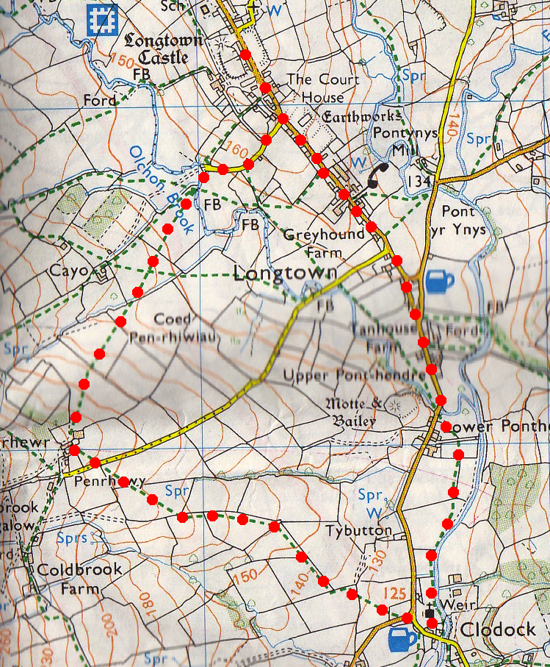
3. Clodock Church. TL, walk along the road to reach Clodock church. This amazing old building has some medieval wall paintings, lovely old pews and a spectacular pulpit, behind which is a memorial stone dating from about AD830. In a dark corner of Clodock church under the gallery are two large stone tablets, mounted on the wall from floor level up to some seven feet, on which a lengthy text sets out the amount of tithes payable to the vicar. The tablets commemorate an episode in the life of the church which has long been forgotten in the local community; a dispute about tithe payments between parishioners and the vicar which led to a court case in 1805. The text on the tablets shows that the medieval system of tithes ‘in kind’ were replaced by cash payments in Clodock parish by 1805 and gives the amount of money to be paid in lieu of produce. Next to the church is the completely unspoilt Cornewall Arms, well worth a visit. Go across the churchyard and down to the river. TL, and at the north east corner of the churchyard you go across a slab-stile that’s been made from an old gravestone and join a wooden fenced enclosed path beyond, the river Monnow is on your R, go thru a gate into F15. Cross this field and over a stile into F16. Cross this field and go thru a gate into F17. Cross this field a across a stile into F18. Straight across this field and over a large stone slab-stile that’s in front of you and into F19. TL and walk along the side of this field to cross over stone stab stiles onto the road. TR, walk along the road for ³/₄ km to return to the car, keep L at the junction. As you get to the south side of Longtown village, you pass "Old Ebenezer Chapel". This chapel has four windows along its side, by each window there is a date stone laid by different people on the 13th June 1889.
1
1
2

3

